ABBYY FlexiCapture12 Connector for BluePrism Release Notes

Table of contents
ABBYY FlexiCapture12 Connector for BluePrism Release Notes 1
Introduction 3
About the document 3
About the product 3
Technical information 3
New Features 3
Proxy support 3
Images export can be turned off 4
Timeout in Singletask connector 4

Introduction

About the document
This document contains a differential description of the ABBYY FlexiCapture Connector release for BluePrism.

About the product
ABBYY FlexiCapture Connector for BluePrism is intended for sending document files from BluePrism to ABBYY FlexiCapture and loading document files and captured data into the BluePrism robotic process automation system.

Technical information
Build# | 12.0.0.171
Part# | 1378/20
Release Date | 24.01.2020
Compatible FC version | 12.0.3.2556 or later

New Features

Proxy support
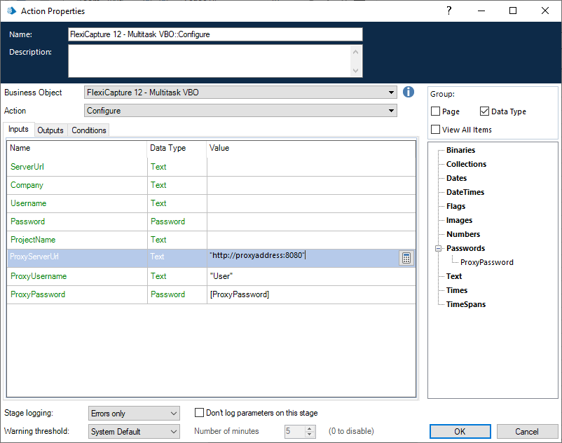
The options for connection via proxy were added into connector.

The testing were performed with the HTTP proxy with the following authentication types
- NTLM
- Basic
- transparent proxy
- IP authentication

Images export can be turned off
In the export connector previously the images were always exported. Now there is a new option connectorSettings.SaveDocumentImages. The default value is TRUE.

Timeout in Singletask connector
Starting from this release the timeout can be specified in Singletask VBO. It allows to customize how long the singletask activity would wait for documents processed in FlexiCapture. The timeout should be specified in seconds. The default timeout is 300 seconds.

