ABBYY FlexiCapture12 Connector for Pega Release Notes

Table of contents
ABBYY FlexiCapture12 Connector for Pega Release Notes 1
Introduction 3
About the document 3
About the product 3
Technical information 3
New Features 3
New supported scenario – FlexiCapture as a service with verification. 3
Web-verification can be integrated into Pega interface 4
Multiple documents can be processed 4
Known issues and limitations 4
Issues in Case Manager instead of Case Worker 4

Introduction

About the document
This document contains a differential description of the ABBYY FlexiCapture Connector release for Pegasystems BPM Platform.

About the product
ABBYY FlexiCapture Connector for Pega is intended for sending document files from Pega BPM Platform to ABBYY FlexiCapture and loading document files and captured data into the Pega BPM.

Technical information
Build# | 12.0.0.57
Part# | 1378/15
Release Date | 26.09.2019
Compatible FC version | 12.0.2.3042 or later

New Features

New supported scenario – FlexiCapture as a service with verification.
Starting from this release the scenario with verification can be used. This scenario includes the following steps:
- Send to ABBYY FlexiCapture the documents, attached to case in Pega.
- [Optional] Receive the link to ABBYY FlexiCapture web verification station.
- Receive extracted data from ABBYY FlexiCapture.

Web-verification can be integrated into Pega interface
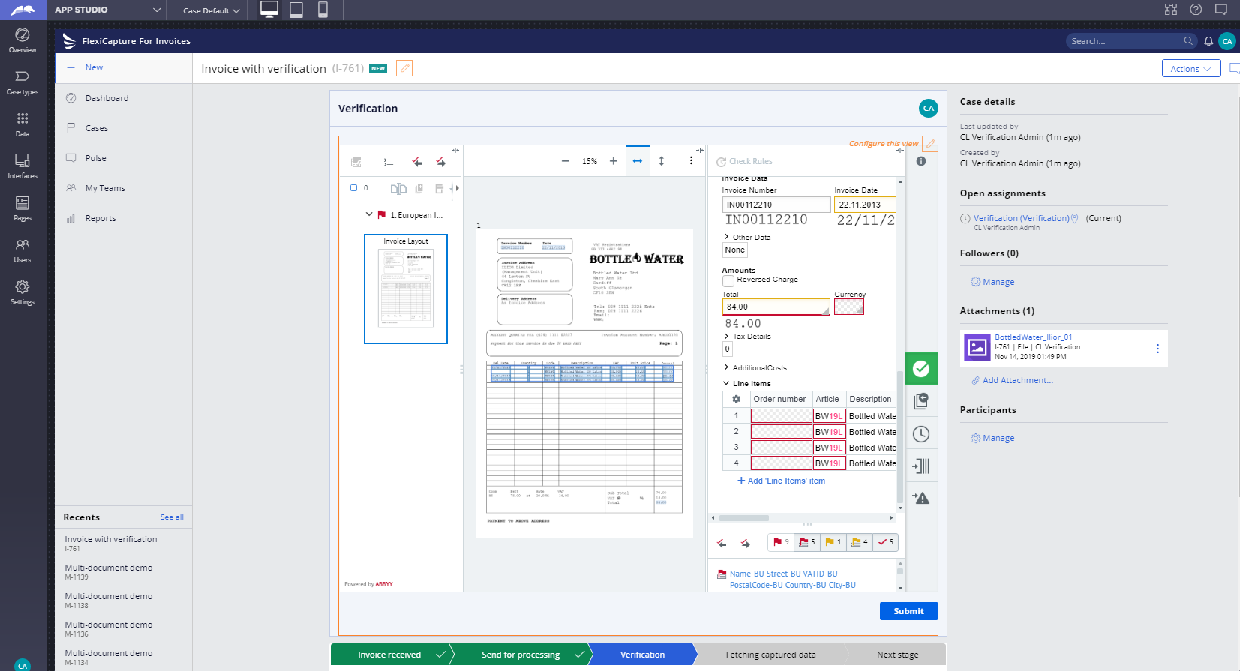
The web-verification station can be shown in Pega web-interface as on the screenshot below. In this case the web-verification becomes a part of solid workflow in Pega platform.

Multiple documents can be processed
In the previous versions of ABBYY FlexiCapture Connector for Pega only one document from case can be send to processing in ABBYY FlexiCapture. Starting from this release all documents attached to case would be sent and one batch will be created in FlexiCapture.

Known issues and limitations

Issues in Case Manager instead of Case Worker
If Case Manager is used with scenario “FlexiCapture as a service with verification” the indication of Web verification loading would not appear. Also the issue “Task is not allowed” can appear.

